

Business Requirements Document (BRD)

Project/Initiative

June 2019

Version 1.0

Company Information

FarEye

# Document Revisions

|  |  |  |
| --- | --- | --- |
| Created on | Document version | Approved by |
| June, 2019 | 1.0 |  |

# Approvals

|  |  |  |  |  |
| --- | --- | --- | --- | --- |
| **Role** | **Name** | **Title** | **Signature** | **Date** |
| Project Sponsor |  |  |  |  |
| Business Owner |  |  |  |  |
| Project Manager |  |  |  |  |
| System Architect |  |  |  |  |
| Development Lead |  |  |  |  |
| User Experience Lead |  |  |  |  |
| Quality Lead |  |  |  |  |
| Content Lead |  |  |  |  |

# Introduction

## Project Summary

### Objectives

The primary objective of developing FarEye for the logistics industry is to help them move their inventory in a supply chain realm smoothly and efficiently to meet their desired level of customer service at the least cost. It serves them with an end-to-end solution so that the companies of supply chain domain can ensure the execution of their day-to-day business operation without any interruption. FarEye comes with three products:

* FarEye Delivery
* FarEye Fulfilment
* FarEye Transportation

FarEye is a SAAS product so no additional environment or software needed to run the daily business operations; it eventually minimizes the setup cost with other systems.

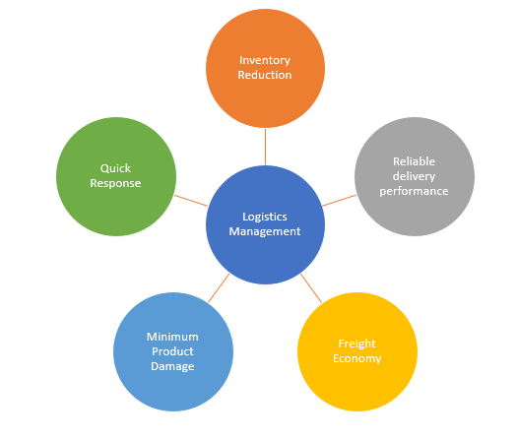

* Provides a real-time visibility to the companies that helps them track their shipments till it reaches to the destination.
* Tracks changes if made by the customers, such as slot time updated for the delivery of parcel.
* Helps you determine the performance of drivers based on their completed jobs out of total jobs assigned, time delay, and delivery time.
* Drives business growth ensuring maximum customer satisfaction and reducing the overall business cost.
* Maintains transparent communication and lets the drivers updated if any changes happen or in process.
* Allows to push bulk data via API or by uploading excel.
* Provides an optimized route based on Postal codes and Go fencing to improvise the efficiency of the delivering shipments with timely delivery.

### Background

From decades the supply chain industry has been experiencing manifold challenges that FarEye has fade away catering to the optimized route, tracking, and real-time visibility. Here is the list of some of those challenges FarEye has overcome:

* Uncertainty around the supply and performance of crowdsource drivers when compared with the dedicated fleet of full-time drivers.
* Leg of logistics where products from supplier/ manufacturing plants are distributed directly to the customers/retail chains with marginal to no handling or storage time
* A real-world multi-commodity Long haul transportation.
* Heterogeneous fleet with capacity and compatibility constraints between commodities and trucks.
* Delivering interactive track & trace experience that retain, engage, and delight customers
* Increasing customer visibility and maximizing convenience by offering the right choices.
* Consumer-driven supply chain network to the customers and multi-party visibility.
* Repetitive data entry and putting the right information for users to improve NPS.
* Excessive turnaround time to roll out process changes based on current KPIs and metrics.

FarEye uses an optimized algorithm to improve the vehicle routing in a volatile transportation environment. It will help the organizations track their drivers, their current position, shipment, current delivery status, and more. This leads to the timely and accurate delivery and therefore, enhances the level of customer satisfaction about the brand. As this product for fleet owners eliminates data repeatability and allows role-based login privileges to perform the certain actions on jobs.

#### Business Drivers

The following business drivers make FarEye important for the logistics and supply chain management:

* Real-time visibility
* Component reusability
* Easy role-based configuration
* Blockchain-enabled platform
* Less time to delivery
* Global logistics visibility
* Transportation management evaluation
* Vehicle auto-routing
* Scheduling and slot interval
* Supply chain efficiency

The organizations will get faster implementation, secure and quick data sharing, and custom integration. The novel functionality of this product, scalability, is required for daily business operation execution and allows them to manage resources (drivers) as per serviceable areas (postal codes and Geo fencing). This brings one-click deployment functionality and can simply be integrated with SOAP web, Rest, EDI and SFTP if needed.

## Project Scope

Catering to the best product for end-to-end eCommerce and supply chain execution and we have been marked an unbeatable flagship in the logistics realm since now. This SaaS based technology solution provides a real-time visibility, predictive intelligence, timely delivery, and customer satisfaction. Custom integration is one of the major features to get the desired functionalities specific to your business operations. Mobility allows you to track the shipment, automation automates the operations, and data analytics ensures the reliable and faster movement of shipments.

### In Scope Functionality

Below is the list of in scope functionality as per current FarEye workflow:

* Flexible delivery scheduling with lag time calculation, customer communication, and slot integration with POS/Web.
* Optimizing route planning to reduce miles per drivers by Routing which can be achieved via a routing algorithm. It includes static & dynamic routing, address geofencing, in-app routing, scheduling dynamic routing, 3D load planning, etc.
* Real time dynamic routing to reduce cost, to keep SLA and ETA intact, and to respond efficiently to the ad-hoc delivery requirements. It covers Foo/Grocery/Service dispatch and truck load dispatch.
* Last mile operations to manage and control parcel until it reaches the end user’s front door.
* Onboarding new drivers (crowdsourcing) to meet the elastic requirements. It includes roster planning, driver registration & assessment, salary planning, training, and more.
* Reducing order processing time for handling shipment at cross dock.
* Optimized long haul movement via IOT and real time visibility.
* Sending proactive alerts and notifications to provide a consistent customer experience and keep the customers updated.
* Transparent status visibility of overall operations of a company.
* No duplicate data entry and keep the data synchronized on FarEye and company’s end.
* Drag-and-drop workflow engine to fulfil ever-evolving logistics needs.

### Out of Scope Functionality

* A
* B
* C

## System Perspective

### Assumptions

### Constraints

### Risks

* Risk 1
* Risk 2

### Issues

* Issue 1
* Issue 2

# Business Process Overview

FarEye Delivery, the most innovative workflow-based vehicle routing & scheduling platform, is made for the **fleet owners** to save their costs through continuous process optimization.

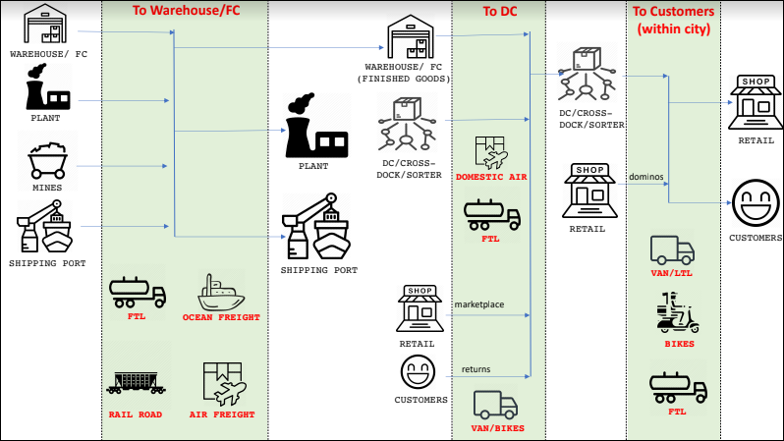

Any business process into the logistics industry runs around multiple modules and submodules, for example – Label Generation, Order Booking, Merchant Dropoff shipment at Service Point, Pickup Cycle, Transport Planning, containerization, and more.

* **FarEye Transportation -** Delivery fulfilment platform for **retailers & shippers** to achieve on-time deliveries and high customer satisfaction.
* **FarEye Fulfillment -** Transportation visibility platform for **freight handling & owning companies** to get real-time and predictive freight visibility.

# Current Business Process (As-Is) -To Be Discussed

# Proposed Business Process (To-Be)

## Label Generation

The objective of Label generation is to create a pre-allocated series of unique labels so that the shipment can be tracked from which merchant this shipment is received. There are three concepts to generate labels:

* **Bilty Book –** This is a traditional approach and used by several shipment service providers, such as DHL.
* **Pre-generated Labels –** As the name defines it is pre-generated labels that merchants use on parcels to track the shipments.
* **Real time generated labels –** This can be achieved by API where you define a range for label series, and the system will automatically generate unique labels which falls in the series.

### Global Series vs Merchant Service

One of the FarEye’s major clients named DHL maintains global series labels across all its customers, for example - 5001366. While in Merchant service a code is appended in the starting or end of the labels so that tracking becomes easier for the customers (For example – Flipkart label is FK0018374, and Amazon label is AMZ0012312).

### Label Generation Process

Following is the flow for the global label generation:

* The customer support team executive initiates the process by clicking **Generate Label** button from the UI.
* A list of merchants is displayed to the customers in drop-down from where the customer can select the desired merchant name for which the label series to be generated. For example – Flipkart, Amazon, etc.
* Enter the quantity of labels to be generated and it can be up to 50K. The system is restricted to generate maximum 50K labels for a merchant in a day.
* Now, the AWB generation process starts and the system uses the reference number series of Sequence Master. The Sequence Master V2 is a tool in FarEye that gives a unique number to an entity/Process.
* The Sequence Master tool saves the generated unique global series into Ref_No_Series and Merchant_Ref_No_Series Data Sources.  
    
  Reference number series in Sequence Master V2 is created based on two attributes, Company/Merchant Code and Running Code.

|  |  |
| --- | --- |
| **Attribute Name** | **Type** |
| Company/Merchant code | String |
| Running Code | Number |

Merchant reference number series is created based on four attributes, Code, Start series, and End series. This series gets expired by default in 365 days.

|  |  |
| --- | --- |
| **Attribute Name** | **Type** |
| Code | Foreign key for merchant code. |
| Start series | Number |
| End series | Number |

* A confirmation email is triggered once the label is successfully generated.

## Order Booking

In case of multipart, one order can have multiple shipments. Therefore, in normal delivery, there is only one order with one shipment. An alert/ notification is triggered to the customer for all the shipments delivery.

There are some basic validations performed on Order Cycle:

* **Serviceable area**
  + **Postal Code –** The postal code of the customer.
  + **Geo Fence –** A virtual perimeter in which the FE must have to perform a certain task of the Hub.
* **Default delivery Date**
  + **Mode of Transport** – All the modes of transportation used for the shipment, such as truck, airways, etc.
  + **Time Slot** – The time when customer wants the parcel to be received at the destination address. Customer can select the desired slot time as per his/her availability to pick the parcel.
* **Reference No series validation** – Each order has a unique reference number.
* **Multipart Shipment** – An order which has multiple shipments.
* **Tentative charges** – The tentative charges are calculated based on Rate Card which further works based on zones, size of parcels (XS, S, M, L, XL), box size (Document, Ring Box, Shoe Box, etc.), weight (<500gms, 500-2kg, 2-5kg, >5kg), and tonnage concepts (10 ton, 20 ton, etc):
  + **Metro zones** – Delhi, Ahmedabad, Bhubaneswar
  + **Non-Metro** – Meerut, Agra
  + **North East India** – Nagaland, Tripura

|  |  |  |  |  |  |
| --- | --- | --- | --- | --- | --- |
| Merchant Code | Size of Parcel | Type of Service | Within Zone 1 | Within Zone 2 | Zone 1 – Zone 2 |
| Amazon | XS | Express | 10 | 15 | 15 |
| Amazon | S | Express | 15 | 20 | 20 |
| Amazon | M | Express | 20 | 25 | 25 |

## Order Booking Process

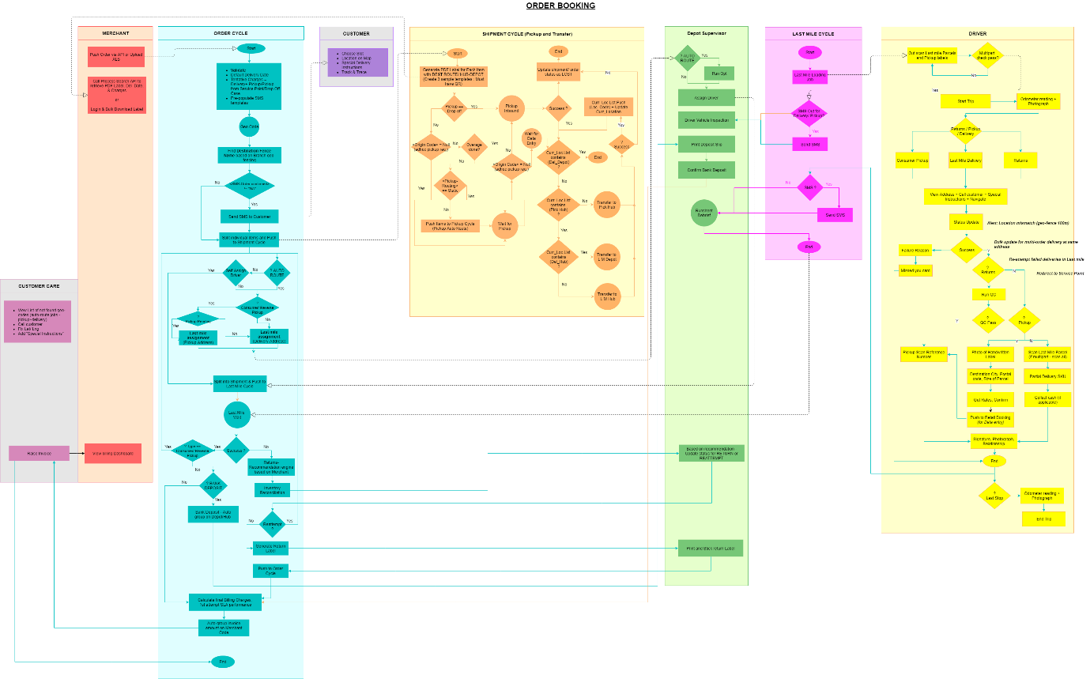

An Order Booking process is the combination of multiple individual processes. Therefore, the successful execution of each of these individual processes leads to a complete order booking process.

A Merchant can push orders into the FarEye either by API or uploading XLS file. Once pushed, the Order Cycle process starts.

#### Order Cycle

1. All the uploaded orders are validated based on
   * Delivery date of the order
   * Tentative charges applicable on the order
   * Templates are prepopulated from the data store.
2. Find the Geo Code based on the provided Latitude & Longitude of the address. If the address is incorrect, then destination fence name is determined based on the Depot (Branch Geo Fence). Therefore, the destination fence name will always vary from customer to customer.
3. An SMS/ notification is sent to the customers as an order confirmation. If the order is not confirmed, split the individual items and then push them into the shipment cycle.
4. The Depot Supervisor checks the route whether it is an auto route or manual route assignment. The auto route is more optimized than manual route assignment. Thus, it is recommended to go with auto routing as the system automatically prepares an optimized route based on geo code received earlier.  
     
   Note* ***Auto routing is still not successful in multiple areas of the Asian countries due to incorrect Geo code (Lat & Long). While it is successful in USA, UK, and European countries.***
5. If it is not auto route, then depot supervisor will check whether it is a self-assign job for driver or not. This functionality helps manager when there are 20 drivers but only one Manager on behalf of them to assign jobs. If the manager takes 2 minutes per runsheet for a driver, then in total the manager will take 40 minutes for assigning jobs manually. In case first 15 drivers take 5 minutes to complete a job, then other drivers to whom the jobs are not assigned will have to wait. This impact the overall efficiency of the drivers. Hence, the self-assign driver is highly recommended than manual assignment. This works when auto routing is not active.
6. When Auto route is active and self-assign driver is not, the system checks the job type is Consumer/Reverse Pickup or not.
7. If it is a Consumer/ Reverse Pickup job, then check whether the pickup is pending for the shipment or not. The origin and destination address will vary depending on which kind of pickup it is.
   * In Consumer pickup, you pay cash. The origin address would be the consumer’s address.

**The Last mile delivery executes two times in the Consumer Pickup order.**

* + In Reverse pickup, you just handover the shipment. **For example**, returning an eCommerce item.
  + In Merchant pickup, there is an enterprise account and, the bill is generated at the end of the month.

If the pickup is pending for shipment, then the flow moves to the Last Mile assignment job with Pickup address. Otherwise, it goes to the Last mile assignment with Delivery address. This is an assignment job for the Manager.

1. If it’s not the Consumer/ Reverse pickup job, then the flow moves to the Last mile assignment with Delivery address.  
   In case of the Last Mile Delivery the origin address is the merchant’s address (e.g. Amazon, Delhi) while the destination address is the consumer’s address.
2. Once the Last Mile Assignment job is created, the list is visible to the Depot Supervisor. If the supervisor finds it as an auto-routing job, then run the optimization and start assigning driver for that job.
3. Once the driver is assigned, manager is supposed to split the shipment into individual shipments and then push them into the Last Mile Cycle. This is because the last mile delivery happens on Shipment level not on the Order level. The flow waits until the Last Mile Delivery is completed.
4. On successful Last Mile it is checked whether the shipment handled by the driver was the Consumer/ Reverse pickup or not. If yes, then the flow comes to Auto Route. Refer to the **Step 6**.  
     
   The Last Mile job creation date may vary every time it is created. Let’s understand it with an example:  
     
   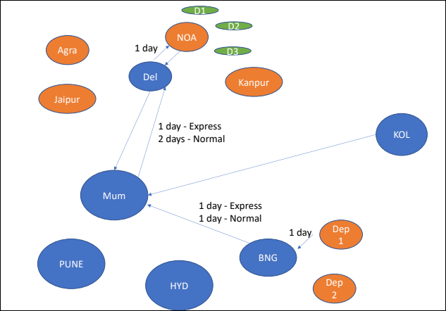  
     
   There is a parcel to be shipped from Bangalore to Delhi and it will cover the routes Bangalore 🡪 Mumbai 🡪 Delhi. The normal delivery of parcel from Bangalore to Mumbai is 1 days while from Mumbai to Delhi is 2 days. So, if the last mile job is created on Bangalore Hub at **June 1**, then the shipment will reach the destination (Delhi) at **June 4**.  
   If the customer updates the date, the default delivery date for the Last Mile job will get updated automatically.
5. If the Last Mile attempt is Failed, then the parcel is returned based on **Returns Recommendation Engine**. The Returns Recommendation Engine works based on the Merchant Code. **For example -** If bank debit card is not delivered successfully in first attempt, then bring it back to the origin (bank).
   * Based on Returns Recommended Engine, the Inventory Reconciliation job is created which goes to the Depot Supervisor.
   * The Depot Supervisor will decide whether the product is to be returned or destroyed and accordingly he updates the status.
   * If it is a reattempt case, the flow comes to **Reattempt** check under the Order Cycle where if the reattempts are pending to be performed, then the flow goes to Auto Route.
   * If it is not a **Reattempt** case, then generate a Return Label. It is a new label containing the destination and origin details on it.
   * The Return Label is printed by the Depot Supervisor and pasted on the top of the parcel to be returned.
   * Push the new order into the Order Cycle and calculate the final charges. For billing charges calculation, refer to **Step 15**.
6. There is a check for Bank Deposit so if the cash to be deposited into the bank, a Bank Deposit job is created. The Bank Deposit is auto grouped on Hub/Depot code.

The auto group is referred as Sub Process where the multiple shipments are grouped together in a bag based on Key. The manager can define key based on which the shipments shall be grouped in the Process. You cannot group shipments of one Depot to another Depot; therefore, only one Depot shipments can be grouped. Auto grouping is done for containerization and bagging as well.   
  
There is another type of grouping called Manual Grouping. The manual grouping is used majorly for containerization and transfer when the loading of all the shipments belong to one Hub/Depot is not possible in one truck. A capacity check is used in this type of grouping which does not work in Auto grouping.

1. The Depot Supervisor can take printout of the slip deposited in the bank. Once done, Depot Supervisor confirms that cash is successfully deposited into the bank.
2. The final billing charges are calculated in the Order Cycle, such as 1st attempt performance SLA, and the invoice of total amount is automatically mapped on the Merchant code, and more.

The auto grouping of billing charges is done on Merchant Code.

#### Last Mile Delivery

The Last Mile Delivery flow starts with the loading job and each loading shipment is scanned to ensure that there is no missing shipment behind.

1. A Last Mile Loading job is created. It is a consolidated job for Consumer Pickup, Reverse Pickup, and Last Mile Delivery. This job is visible to the drivers and they scan all the last mile parcels and pickup labels.

The driver has 60 shipments in the list, out of which, 52 shipments are delivery and 8 are reverse pickup so the driver will scan 52 parcels and 8 barcode labels. It’s just scanning the paper barcode. 8 stickers are attached when the parcel is picked from the consumers.

1. There is a multipart check to scan all the shipments. This helps when you don’t know how many parcels to be scanned or how many parcels the driver is carrying, then multipart scanning is preferred to go with.
2. If required, an SMS can be triggered to the consumer about the delivery/ pickup.
3. The Depot Supervisor is supposed to perform the vehicle inspection, such as truck condition, wheels condition, driver is wearing uniform or not, all the mandates fulfilled by the drivers, some required compliance, etc.

FarEye does not handle vehicle inspection. The vehicle inspection process is adhoc from customer to customer.

1. Once the loading is done, driver starts the trip. Also, the driver records odometer reading and captures a photograph of it. Based on the type of job (Last mile delivery, consumer pickup, or reverse pickup) the driver will be able to,
   1. View the customer address
   2. Call customer
   3. View special instructions - *The special instructions are shared by the customers during the order placement.*
   4. Navigate – Allows driver to view the Google map and navigate to the customer’s address accordingly.
2. The driver can mark the status as Success or Failed. On **Success** status driver will further check whether it is a Return job or not.
   1. If it’s a **Return** job, the driver will perform Quality Check (QC) as well. There is a predefined quality checklist along with the driver to perform quality check while returning the shipment. **For example:**  The job is about Laptop return, then driver will check the laptop color, charger, IMEI number, box number, etc.  
        
      This QC list contains:
      * Item List
      * Item Reference Number
      * Item Name
      * Item Code
      * Item Photograph
      * Item Status
      * Length
      * Height
      * Width
      * Weight
      * QC questions

If QC passes, the driver will scan the reference number of the Pickup item and take the signature, photograph, and relation status from the consumer.

* 1. If it’s not a Return job, then confirm whether it’s a Delivery or Pickup job. If it’s Pickup, the driver will perform the following actions:
     + Take a photograph of handwritten label pasted on the parcel.
     + Check the destination city, postal code, and size of the parcel.
     + Based on the address, postal code, and size, the driver gets the rate of shipment and confirms it.
     + Push details to the Retail Booking process for data entry. This is a part of Parcel Shop Booking process.
     + Driver will scan pickup reference number and take signature, photograph, and relation status from the consumer.

If it is Last Mile Delivery, then Driver will scan all the parcels he will be delivering. In case of multipart shipment, the driver needs to ensure that all shipments are scanned.

* + - A scenario of Partial Delivery SKU may arise when shipment of food items is delivered.   
      **For Example:**  
      The customer orders 2 packet of milk, 1 packet of butter, and 1 packet of bread and their cost is 22/milk packet, 50 for butter, and 35 for bread. The total cost would be 129. Let’s suppose 1 packet of milk gets broken while delivering the order to customer so the cost of 1 packet milk will reduce from the total amount (129-22=107).

Here, the shipment is 1 so as the Order but 3 SKU items out of which one is not successful.

* + - The driver will collect cash (107rs cash instead of 129rs) if applicable. There are different modes of collecting payment in FarEye, such as Paytm, Wallet, Debit Card, UPI, etc.   
        
      Though the digital cash collection is highly recommended as these are safe, reliable, and less cash handling for Depot supervisor.   
        
      **For example:** There are 1000 orders every day and each order’s cost is 200, then handling 2,00,000rs will be immensely high for the Depot supervisor on daily basis.
    - Driver will take signature, photograph, and relation status from the consumer.

1. If the driver marks the status as Failed due to any reason like customer is not available, then a **Missed you card** is attached and the flow ends.

As of now this functionality is not popular or being used among multiple customers.

1. In case of Last Stop the driver records the Odometer reading and takes a photograph of it. Now, the driver will end the trip.

If you want the driver should come back to Hub after Last Hub, you can put some checks or geo code in FarEye accordingly.

1. The Depot Supervisor performs Runsheet Debriefing on following activities and the Last Mile Cycle flow ends.
   * Failed Deliveries
   * Cash Collected
   * New Pickup / Return Success

### Shipment Cycle

In FarEye there are three sources of pickup:

* **Marketplace** – Small sellers who are selling online. Challenges with marketplace is that the volume of parcels is unpredictable. Using static routing is not a good approach when the volume of parcels to be picked up is not predicted. Therefore, whenever business requirement comes to pick parcels, but the number fluctuates every time you visit the marketplace, then you go with the dynamic routing, not static routing.
* **Consumer** – When you do home to home pickup, static routing does not work.
* **Merchant Location / Service Point** – Here, the volume is predicted and there is always visibility of time, hence, you go with Static routing. Merchants usually have their own dedicated fleet for picking parcels.

The permutation & combination of the above sources will vary from company to company for pickup solutions. Depending on the business scenario companies use dedicated or shared fleets.

* **Dedicated Fleet** – Drivers who perform pickup from the source area and deliver it to the last mile.
* **Shared Fleet** – Drivers who perform both pickup and delivery.

Following is the flow for Shipment Cycle in an Order Booking process:

1. The PDF labels are generated in the Shipment cycle for each item to be shipped. In case of Multipart shipment order, each shipment of the order has a PDF label attached on its boxes.
   1. Each PDF label must include DEST ROUTE / HUB-DEPOT. The DEST ROUTE could be the postal code or fence name. This helps in last mile sorting and route optimization.
   2. There are 3 sample templates to create labels and each of them must have the QR code. FarEye also facilitates companies to customize it as per their business needs.

If the company follows Geocode for delivery, then fence name helps in tracking the customer’s address, otherwise the postal code of the address. If Geocode and fence name are not there, then destination address can be tracked from the Depot name.  
  
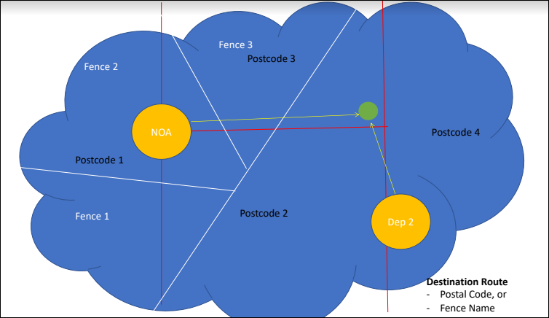

1. There are three types of pickups in FarEye named Drop Off, Pickup, and Drop Off at Service Point.
   1. If the Pickup type is Drop off, then a Pickup Inbound job is created.
   2. If Pickup type is not Drop Off, system will check the origin code. If the origin code is found as NULL (the origin address is not available in the Merchant Master), then the address is manually added as an adhoc pickup request. The flow waits until the pickup scan happens.
   3. If this is not an adhoc pickup request, then system checks whether it’s an Overage Scan or not.   
        
      **Let’s understand the Overage concept with an example:**  
        
      Amazon receives millions of orders every day so when a new order is received, multiple processes happen in parallel. The placed order details are visible to the warehouse where the parcel is picked and packaged. At the same time, a request goes to the Blue Dart about the shipment handover. Through an API the order details are pushed, and Blue Dart evaluates the data and then pushes it further to the Last Mile driver for pickup. If the shipment is packed and ready but due to some delay in the network, details are not reached the driver because it’s somewhere in the middle of validation process. Someone from the Blue Dart came to the Amazon warehouse for scanning parcels and he finds a pile of loads. In that pile of loads, there might be some shipments those details are not reflecting in the mobile app of Blue Dart executive due to the network delay. Those items are called **Overages**. The executive will scan all those items and perform quick validations like Blue Dart shipping label is pasted on the parcels or not. If the labels are there and these are valid as well, then all the shipments can be picked up from the Amazon warehouse. In logistics there is no point of throwing an exception regarding overage parcels and sending a guy again to pick those items. This is being allowed so that shipments never get delayed in the Logistics.
2. If no overage scan is received, then we confirm the nature of pickup routing which can be either Static or Dynamic. If it is Static routing, then wait for pickup scan to happen. Else, push the items to Pickup Cycle for Pickup Auto Routing.
3. In the scenario when overage scan is received, then an Inbound Pickup job is created. If the Runsheet Debriefing is already done by the Depot Supervisor, then Inbound Pickup process does not happen neither in case of Consumer Pickup.
4. Once the pickup scan is done, we check the origin code and if it is found as NULL, an Adhoc Pickup request is created, and the flow will wait until the data entry is done. If the origin code is not NULL, then shipment moves to the Inbound Pickup process.
5. If the Inbound Pickup is not successful due to any damage/ missing shipment, the order status is marked as LOST and the shipment is updated.
6. If there is no missing or damage shipment (means Inbound Pickup is successful), the current location with its current Depot is updated. The above flow runs in a loop until the shipment reaches from Pickup Depot/ Hub to the Delivery Hub/ Depot:
   1. If current location is equal to Delivery Hub, the flow ends.
   2. If current location is not equal to Delivery Hub, then confirm whether the current location is Pickup Hub or not. If shipment is not at Pickup Hub, then it is transferred to the Pickup Hub.
   3. Once the transfer process gets executed successfully, push the current location of shipment which is added into an array and update the current location. The flow will again move to the **step a**, to check the current location.
   4. Once the shipment contains the Delivery Hub, it is transferred to the Last Mile Depot. Otherwise, it is transferred to the Last Mile Hub.

## Inbound Process

There are four types of inbound processes in FarEye named Pickup Tours, Line Haul, Containers, and Overage. All the scanned shipments picked from the source area are pushed into the Inbound Process where the auto grouping of shipments is done based on a key. This is used to trace that no mismatch shipment is happened and/or no shipment is missing.

Following is the flow for Inbound Process:

1. The key for auto grouping is the driver code/ employee code in inbound pickup.
2. There is an Inbound Sub Process where a list of shipments is prepared. The list of all the scanned Inbound Pickups is visible to the Depot Supervisor.
3. The Depot Supervisor can select one option out of Pickup Tours, Line Haul, Bag, and Overages, and can start unloading for the driver accordingly.
4. There must a seal on the truck which is confirmed by the supervisor. If the seal is damaged, Depot Supervisor reports about the damaged seal and an alert is also triggered for the same. Else, the Depot Supervisor will start scanning of all the inbound items for the driver.
5. If the reference number is not found and there is no damaged parcel as well, then the flow ends. While in case there are 453 items out of which 3 are overage items and 450 are actual shipments, then the list will be prepared for 450 items, not for 453.
6. If the reference number is not found but the item is physically present, then confirm it is a pickup item, Bag, or Long Haul.
   1. In case of Long Haul and Bag, the supervisor will update the actual shipments and bag them at the current location. These details are uploaded.
   2. The overage items will be placed into the Overage/ mis-sort area.
7. In the scenario of missing shipment, Depot Supervisor selects the reason (missing/ damage) and takes a picture. The flow ends at Supervisor end.
8. When Inbound process is successful, the flow ends with Success End status. Else, it is checked there are missing & damaged items or not. A list of all the damaged & missing items is reported to the Depot Supervisor who selects the damaged item from the list and resolves the issue. If it is resolved, the flow ends with the status LOST.

## Containerization and Transfer

Based on Pickup, there is one origin location and destination address from which we get the postal code of origin and destination location so as the Depot Code and Hub Code of origin and destination location.

* **Hubs –** Big units for long haul network.
* **Depots –** These are the small units of a Hub and are connected to it. These units take care of the first mile and last mile of the network.

Following is the flow for Containerization and Transfer:

Transfer Planning is an optional step which FarEye usually avoids because there are already several TMS organizations who are leaders in finding the best possible route for the transportation. You can activate or deactivate this module (TRANSPORT_PLANNING_MODULE) in the FarEye web application as per business needs.

Containerization is a process of consolidating multiple shipments into a bag. So, there can be some scenarios where you will need containerization or sometimes not.

1. When containerization is required, a job named **Add to Container** is created which is visible to the Depot Supervisor. If not required, then the boxes are transferred without containerization.
2. There are two modules in FarEye to add shipments to containers:
   1. In the Web module, Depot Supervisor scans the items and then places them into a container. Both multiple shipments into multiple containers and multiple shipments into one container are possible. The containerization is done based on the destination location.
   2. In Mobile based module, Depot Supervisor scans the item and then scans the container to validate the item is placed into the correct container.
3. Once the scanning is done, there is manual check to confirm the container is full or not.
   1. If the container is not full, keep adding items into the container either by the web-based module or mobile based module.
   2. If the container is full, seal the container.
4. Put a Container No. on the sealed container which must always be a unique number. Besides, there is a seal number which is not unique, but it’s used to ensure that seal remains intact on the container.
5. The sealed container after putting Container No. on it is sent to the Transfer Process.

### Transfer Process

It is always the company’s decision whether they want to use their own fleets or third-party fleets to transfer the container.

If the companies use their own fleets,

1. They decide a route to transfer container either by Static or Dynamic route.
2. If it is a Static route, wait for Pickup scan to happen. Otherwise, push it to the Pickup process.
3. Once the pickup scan is done, the Inbound Pickup Scan happens for all the Pickup Depots and then moves to the Pickup Hub.
4. If the Inbound Pickup is successful, the flow ends as Transfer Successful. Otherwise, mark the status as LOST and the flow ends as Transfer Failed.

If the companies use third party fleets (3PL) (this is largely the scenario of Hub-to-Hub transfer),

1. They decide whether it will be a route wise sorting or not. In route wise sorting, the companies sort their containers and place them on the door of their premises. This is because the person who will be loading the container does not belong to the company, so they are mostly not allowed to enter to the company premises.
2. If it is not a route wise sorting, Depot Supervisor will scan container so as the staging code. This is because some big boxes are sent without containerization. Staging code is like a QR code or Bar code.
3. The flow comes at Loading under 3PL fleet of Transfer process. Now, the actual loading of containers starts where containers or shipments are scanned and then you place the destination address on it. The destination is the final address where the containers will be transferred to.
4. Auto group the containers based on Destination Hub.   
    **For example:** The route is Mumbai 🡪 Pune 🡪 Hyderabad 🡪 Bangalore. 5 containers are loaded to drop at Pune location while 10 for Hyderabad and 35 for Bangalore location. The auto grouping of containers is done by the Depot Supervisor based on Pune, Hyderabad, and Bangalore.
5. In Load Dispatch, generate a manifest for the auto grouped containers which contains the HSN (Harmonized System of Nomenclature) code. The HSN code is always unique.   
    **For example:** If you ship a car, it will have a unique HSN code, while on shipping 4 tyres and 1 battery of car, there will be 2 HSN codes.
6. You can view, print, or email this manifest to the Transport/ Fleet owners. The Depot Supervisor selects Load (e.g. 3 loads), enter the transport details, tonnage, mode (air, road, rail, ship), and destination and then dispatches the load.
7. The Transporter is also notified for the Placement Process.
8. A trip is triggered to control and provide real time visibility of loaded truck. (In Development). Once done, the load dispatch process ends.
9. An Inbound Process for Truck No. is created (as per Mumbai 🡪 Pune 🡪 Hyderabad 🡪 Bangalore route, 3 Inbound Processes for the Truck No is created).
10. If the Inbound Process is successful, the flow ends with Success status. Else, update the status as LOST and the flow will end with Failed status.
11. When the Transfer Process is successful (the bag has reached the destination location (e.g. Pune), the container must be unopened. We start scanning shipments of the container. If everything is successfully received with the container, end the flow with Success. Otherwise, update the status as LOST.

## Transport Planning

OTM and TMS are two renowned leaders in the transport planning. For transport, FarEye provides the shortest path based on network master, route wise cost, and time. The transport price will vary from route to route.

Dijikstra is an algorithm used for APL optimization which helps in finding the ideal route to dispatch loads. As per the above diagram the best route is 0-4-9. The system also helps the organizations decide which kind of truck or transporter is suitable for load to dispatch.

### Transport Planning Flow

Following is the Transport Planning flow used in FarEye:

1. The Origin-Destination details are pushed to Transport Planning from the Containerization Process.
2. The supervisor will trigger planning and auto-group the transport based on Destination Hub key. The total tonnage pushed is calculated at Transport Planning Service Point. FarEye uses Dijikstra algorithm to find an optimized route which is ideal to transport for a business (in terms of cost and price). **For example:** <Delhi 🡪 Agra 🡪 Mumbai>.
3. The supervisor will auto-group transport to the next Hop.
4. In Transport Indent, calculate the total tonnage once again and find a transporter for shipment based on SOB, Priority, and other related details.
5. The Hub/ Depot Supervisor can view the total tonnage with recommended transporter details. The supervisor assigns a Transporter, gate number, and time of placement based on the type of load to be dispatched. Once done, the supervisor will raise an indent.
6. An alert is triggered for the Depot supervisor with the name of transporter assigned to the indent.
7. An SMS is sent to the Transporter if assigned by the Supervisor for a specific indent. This expires in 1 hour.
8. If transporter confirms the indent, he will provide a vehicle number and driver details. These details get visible to the Depot / Hub supervisor.
9. One indent can have multiple vehicle requests. So, based on the requirement of vehicles (e.g 3 vehicles), split drivers per vehicle and create a placement task in the Placement module. The placement task is a job which explains time of the placement for truck (e.g. The truck A is supposed to be placed at 9:00 AM for loading). This task becomes visible to the Gate Incharge.
   1. If the time of placement is more than 60 mins, then the task gets expired and Gate Incharge updates it. Else, the Gate Incharge checks whether truck is Placed on or before time or not.
   2. If the truck has arrived on time and placed successfully, Gate Incharge will confirm the Gate Number to dispatch. Else, he will raise an alert to dispatch.
   3. Wait until the dispatch happens; there is an average dispatch time for a truck at the depot/ hub and once the supervisor confirms dispatch, the placement flow ends.

## Service Point

Service Points are like small parcel shops who perform mile to mile deliveries for their customers. These are the source of revenues where customers can walk in and drop off the parcels. From those service points, the network gets linked. These are popular in south-east asia.

### Retail shipment booking at Service Point

Retail customers are small shops who sell products online and consumers place order from there. For products’ delivery, there are some Service Points from where the consumers can pick their ordered product.

1. Customer walks-in with a handwritten label to Service Point (SP) agent.
2. The SP agent clicks **New Walk-in** and enters Customer mobile number and basic details, adds parcels, selects destination state, city, and postal code, and selects size of parcel.
3. There is a Data Source Master to fetch the postal code details.
4. There is a Connector where the Rate Calculation API is being run to calculate rate and ETA based on origin postal, destination postal code, size, and service type. The rates and zone are sent back to the SP agent.
5. Once the rate is confirmed, take a photograph of parcel. If there are more parcels to be added, then flow moved to Add parcel until it the last parcel to add.
6. If there is no parcel left for adding, collect amount and sent an email receipt for Retail Booking Process.
7. The system checks whether the booking is done from SP or driver. In both cases details are sent for data entry job along with the photograph of handwritten label. The Customer Service Agent will throw and alert for pending data entry job, if any. If the booking is done from SP, the SP commission is also calculated and sent to the Customer Service Agent.
8. Customer Service Agent will push details to Order Cycle. The order cycle is updated as per details and once the order cycle completes, the flow ends.
9. SP views the handed over shipments, wait for the pickup scan to happen either it is dynamic or static.

### Merchant Drop off Shipment at Service Point

The Supervisor clicks New Drop Off at Service Point and keeps adding parcels by scanning them one by one. Once all the parcels are added, checkout to publish Pickup Scan Event. The flow will move to Waiting Shipment Cycle process to execute Shipment cycle. At the same time, the Service Point commission is calculated. The supervisor views all the pending handover shipments and then waits for Pickup Scan to happen. Once pickup scan is successful, the flow ends.

# Business Requirements

The business requirements are priorities as follows:

|  |  |  |
| --- | --- | --- |
| **Value** | **Rating** | **Description** |
| 1 | Critical |  |
| 2 | High |  |
| 3 | Medium |  |
| 4 | Low |  |

## Functional Requirements

| **Req#** | **Priority** | **Description** | **Rationale** | **Use Case Reference** | **Impacted Stakeholders** |
| --- | --- | --- | --- | --- | --- |
| **Basic Functionality** | | | | | |
|  |  |  |  |  |  |
|  |  |  |  |  |  |
| **Security Requirements** | | | | | |
|  |  | All the existing and in process features of any of the FarEye’s products shall be limited to the users with Team Lead, Managers, and System Administrator associated with FarEye. |  |  |  |
| **Reporting Requirements** | | | | | |
|  |  |  |  |  |  |
| **Usability Requirements** | | | | | |
|  |  | User interface shall be responsive to allow company owners view on multiple devices, such as laptop, desktop, and tablet. |  |  |  |
| **Audit Requirements** | | | | | |
|  |  | Any changes shall be appended with the user ID, date, and time stamp. |  |  |  |

## Non-Functional Requirements

|  |  |
| --- | --- |
| **ID** | **Requirement** |

# Appendices

## List of Acronyms

## Glossary of Terms

## Related Document